2nd WEEK INTERNSHIP REPORT


NAME : MUHAMMAD SAAD MALIK
RED TEAM INTERNEE
INSTRUCTOR : TALAL REHAN
IT-SIMPLERA INSTITUTE
TABLE OF CONTENT
1ST TASK IP CONFIG/ALL INFO
2ND TASK BASIC NETWORK COMMANDS
3RD TASK ROUTER VS SWITCH
4TH TASK IP ADRESSING
5TH TASK OSI LAYER EXPLAINATION

INTRODUCTION:
This report covers the work completed in Week 02 of the IT-SIMPLERA Cyber Security Analyst Internship Program, focused on Computer Networking Fundamentals and Network Configuration. Since defending a network first requires understanding how it operates, this week's tasks built a practical and theoretical foundation in networking basics — identifying a machine's network configuration, running core diagnostic commands, comparing key networking devices and addressing schemes, and studying the OSI Model layer by layer.
TASK 1st:
Command “ipconfig /all”
ipconfig /all is a Windows command-line utility that displays the complete TCP/IP configuration for every network adapter on a machine. Unlike the plain ipconfig command (which only shows IP address, subnet mask, and default gateway), the /all flag adds the MAC address, DHCP status, DNS servers, and lease timing giving a full picture of how the machine is connected to the network.
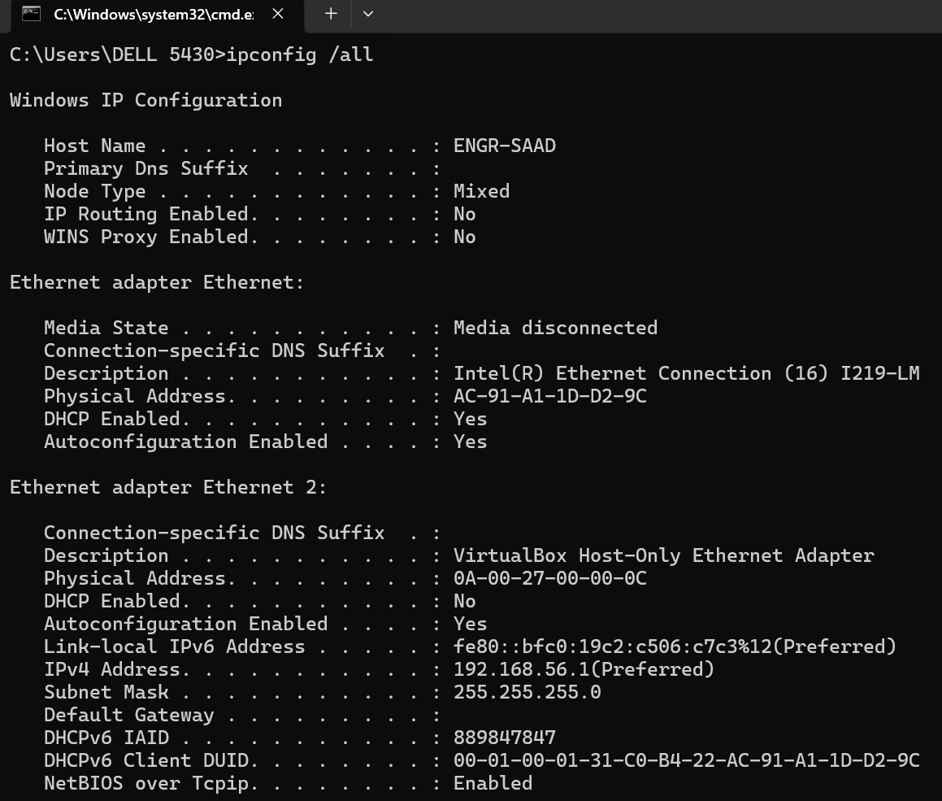
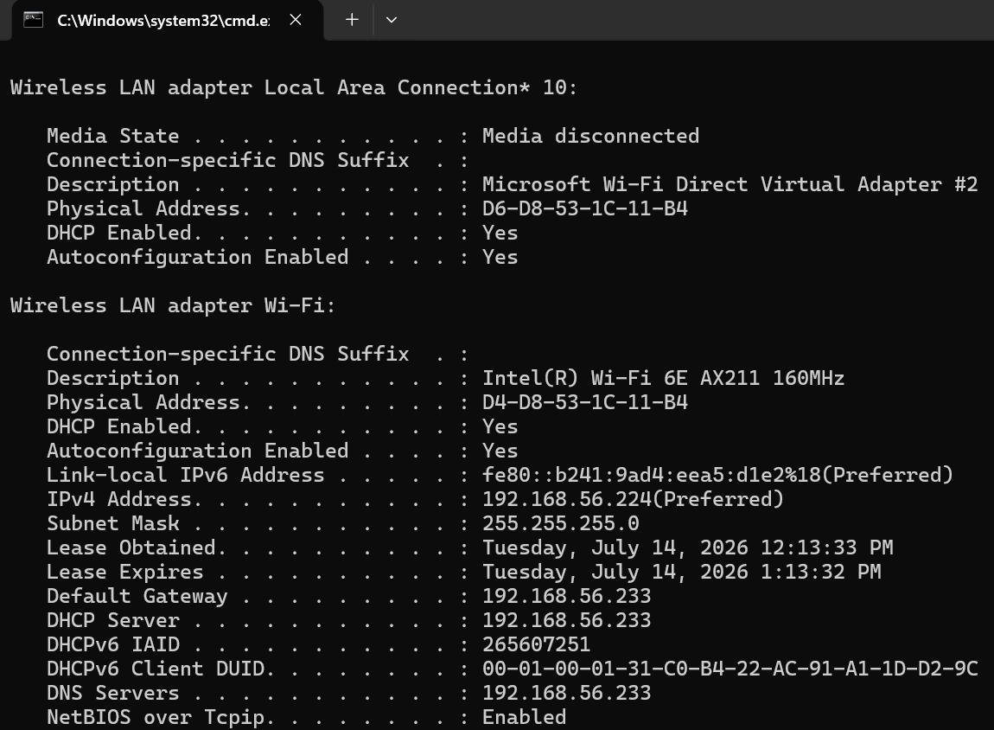
IPV4 ADDRESS | 192.168.56.224 | This is private Layer 3 IP Address which identifies this node in the LAN and show Router where to deliver packets belonging to this IP Address. Its like Like Your Home address
MAC Address | D4-D8-53-1C-11-B4 | MAC address is the layer 2 physical address that is burned on the NIC card, its unique 48 bits address.Switch Uses MAC address to deliever Frames it’s the Network Segment
Default Gateway | 192.168.56.233 | Its also an IP address that is assigned to the exit Interface of the network it acts as a gateway between your network and internet. Whenever a packets is send to gateway address it exit the packet from the interface.
TASK 2nd:
- IPCONFIG /ALL
- It's a Windows command that displays the complete TCP/IP configuration for every network adapter on your machine.
- It shows your IPv4 address, which identifies your device on the local network.
- It reveals your MAC address (Physical Address), the hardware ID of your network card.
- It also shows the Default Gateway, Subnet Mask, DHCP status, and DNS servers in use.
- It's typically the first command run when troubleshooting any network issue, since it gives a full snapshot of a machine's network identity.



- PING GOOGLE.COM
The ping google.com command tests the connectivity between your local machine and a remote host — in this case, Google's servers. It works by sending four ICMP Echo Request packets to google.com and waiting for Echo Reply responses in return. Each successful reply reports the Round-Trip Time (RTT), which is the time in milliseconds it took for the packet to travel to the destination and back.
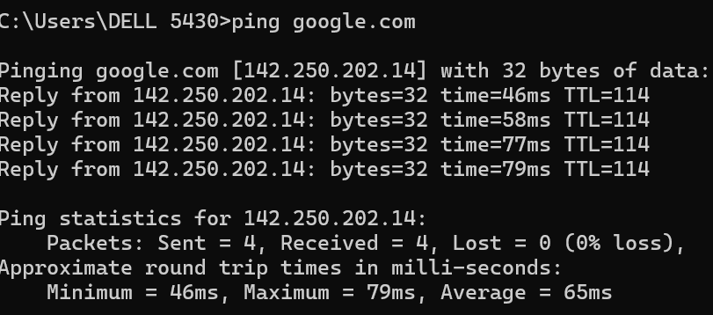
- TRACERT GOOGLE.COM
The tracert google.com command traces the exact path your packets take from your machine to reach google.com, hop by hop through each router along the way. Each line of output shows one router's IP address and its response time in milliseconds. This helps pinpoint exactly where a delay or failure is occurring on the route, rather than just knowing the connection is slow. Some hops may show "* * *" instead of a time — this usually just means that router silently drops ICMP requests, not that there's an actual fault. Once it reaches the destination, it displays "Trace complete."
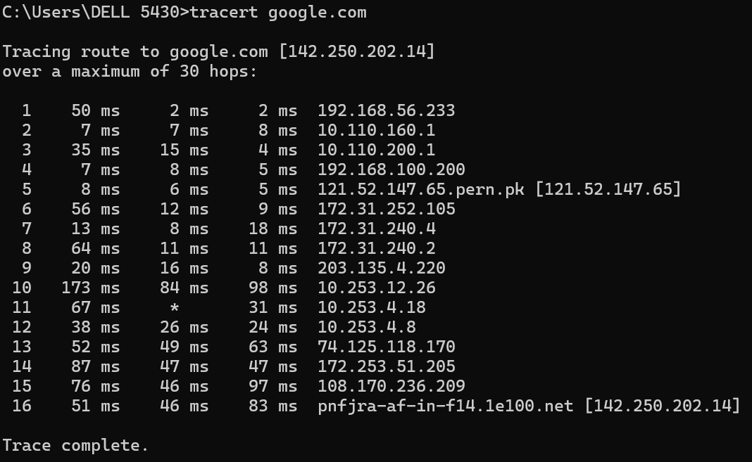
- NSLOOKUP GOOGLE.COM:
The nslookup google.com command queries a DNS (Domain Name System) server to resolve the domain name google.com into its corresponding IP address(es). The output shows which DNS server answered the query (listed under "Server"), along with the IP address(es) returned for the domain — often both an IPv4 and an IPv6 address. This command is useful for verifying that DNS resolution is working correctly and for identifying exactly which DNS server your machine is using. From a security standpoint, analysts use nslookup to investigate suspicious domains, check for DNS hijacking, and confirm that a domain resolves to the address it's supposed to.
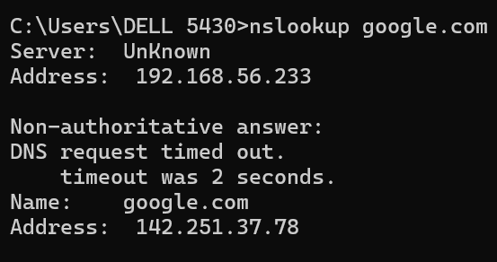
- ARP -A:
The arp -a command displays the ARP (Address Resolution Protocol) cache on your machine — a table of IP-to-MAC address mappings that your computer has learned through recent communication with other devices on the local network. For each entry, it shows the Internet Address (IP), the corresponding Physical Address (MAC), and the Type (dynamic, meaning it was learned automatically, or static, meaning it's manually configured or reserved). This table matters especially for security, since ARP poisoning (or ARP spoofing) attacks work by corrupting these mappings — tricking a device into sending traffic to an attacker's MAC address instead of the legitimate one, enabling a man-in-the-middle attack. Reviewing the ARP cache periodically can help spot unexpected or duplicate entries that might indicate this kind of attack is underway.

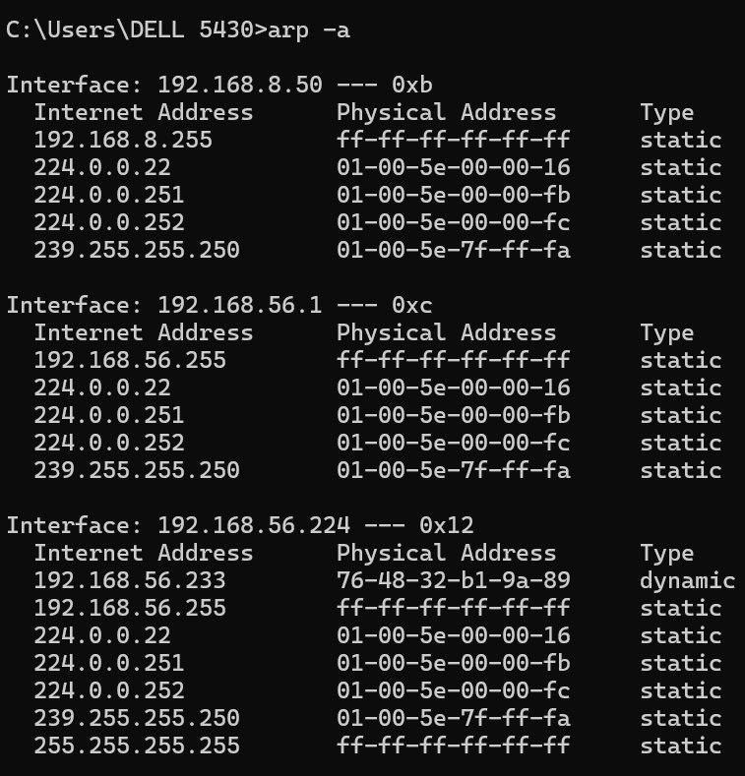
3rd TASK:
COMPARISON POINT | ROUTER | SWITCH
PRIMARY FUNCATION | Connectes multiple networks together & routes packets between them based of IP address | Connects different nodes with A Local Area Network & farwards frame based in MAC addres
LAYER | Layer 3 Network Layer | Primary On L2 But also On L3
ADDRESSING USED | Router used layer 3 address known as IP Addresses ( V4 & V6) | Switch uses Layer 2 Physsical unique address known as MAC (MEDIA ACCESS CONTROL) Adress
BROADCAST DOMAIN | Router separate Broadcast domains & stops broadcasts from crossing into other network | All ports are single broadcast domain by default
No. PORTS | Typically 2-8 Ports | Typically 8-48+ Ports
PROCESSING SPEED | Slower due to deencapsulation till 3rd layer for examining IP Address | Very Fast forwarding decision are made in hardware at wire speed

4th TASK:
IPV4 | IPV6
32 Bits (4 Bytes) | 128 bits (16 Bytes)
Four Decimal octets separated by dots | Eight groups of Hexadecimal digits separated ny colons
Approx 4.3 Billion addresses ($2^{32}$) | 340 Undecillion addresses ($2^{128})$
Manual Or DHCP is used for Assignment | Supports SLAAC menas devices can generate their own ip without DHCP server
NAT is widely due to limited number of Addresses for the world | No NAT is used because everyone can get unique IPV6 Easily
Security is optional , must be cnfugured | IPSEC

5th TASK:
OSI LAYERS AND THEIR FUNCTION:
- PHYSICAL LAYER:
Transmits raw bits (0s and 1s) over a physical medium like cable, fiber, or radio waves
PROTOCOL: ETHERNET
DEVICES : HUBS
- DATA LINK LAYER:
Handles node-to-node delivery within the same network segment; packages data into frames and adds MAC addresses
PROTOCOL: ETHERNET
DEVICES: SWITCHES
- NETWORK LAYER:
Handles logical addressing and routing, determining the best path for data between networks
PROTOCOL: IP
Device: ROUTERS
- TRANSPORT LAYER:
Ensures reliable, end-to-end data delivery, handling segmentation, flow control, and error correction
PROTOCOL USED: TCP , UDP , PORT NUMBERS
DEVICES: FIREWALLS
- SESSION LAYER:
Establishes, manages, and terminates communication sessions between applications
PROTOCOL: NetBIOS
DEVICES:GATEWAYS

- PRESENTATION LAYER:
Translates, encrypts/decrypts, and compresses data so both endpoints can understand the format
PROTOCOL: SSL/TLS
DEVICES: ENCRYPTION GATEWAYS

- APPLIATION LAYER:
Interfaces directly with end-user applications, providing services like email, web browsing, and file transfer
PROTOCOL:HTTP, HTTPS & DHCP
DEVICES: APPLICATION SERVERS

